**一、**

Bonus1、Bonus2都有做。

**二、**

**(1)CRR Binomial Tree & Bonus1: Option_Average_CRR.py**

*def* simulate_stock_price(*StInit*, *u*, *d*,*layers*):

*class* Tree_Node:...

*def* average_CRR(*StAve*, *StInit*, *K*, *time_elapsed*, *time_left_to_maturity*, *r*, *q*, *sigma*, *M*, *layers_prev*, *layers*, *type*, *log_arrayed*):...

# main

StInit = 50

StAve = 50

K = 50

r = 0.1

q = 0.05

sigma = 0.8

time_left_to_maturity = 0.25

M = 100

layers_prev = 100

layers = 100

直接調整 **#main** 下面的變數，呼叫函式存入變數，再印出即可(所有參數以及函式都已預先輸入好，直接執行即可以看到精美的結果)。

輸出看起來會是這樣 :

============================================================

[ Save,t = 50 | time elapsed = 0 ]

[ log arrayed = False ]

------------------------------------------------------------

(CRR Binomial Tree) Price of European Average Call : 4.7354

============================================================

[ Save,t = 50 | time elapsed = 0 ]

[ log arrayed = True ]

------------------------------------------------------------

(CRR Binomial Tree) Price of European Average Call : 4.6949

...

此外，下面還有使用 **multiprocessing** 套件執行的程式碼 (我已將其註解掉)，可以用，但因為每個程序執行速度不同，輸出的結果跟原本的順序不同，會亂掉。所以想順便在此請問老師/助教如何解決這個問題。

然後是 Bonus1 的表與圖表(使用 python 的 **matplotlib** 套件繪製):

參數設定:

StInit = 50

StAve = 50

K = 50

r = 0.1

q = 0.05

sigma = 0.8

**time_elapsed = 0**

time_left_to_maturity = 0.25

layers_prev = 100

layers = 100

M = [50, 100, 150, 200, 250, 300, 350, 400]

# European Option

equal_EU = [5.0781, 4.7354, 4.6821, 4.6652, 4.659, 4.6543, 4.6514, 4.6498]

log_EU = [4.9278, 4.6949, 4.6699, 4.6586, 4.6531, 4.6505, 4.6488, 4.6478]

# American Option

equal_US = [5.7115, 5.4146, 5.3785, 5.3678, 5.3624, 5.3571, 5.3588, 5.3561]

log_US = [5.5737, 5.3904, 5.371, 5.3619, 5.3587, 5.3566, 5.3555, 5.3547]

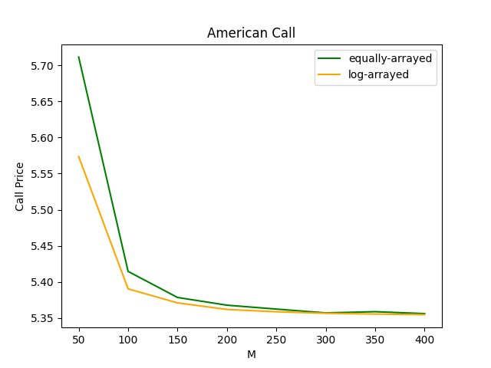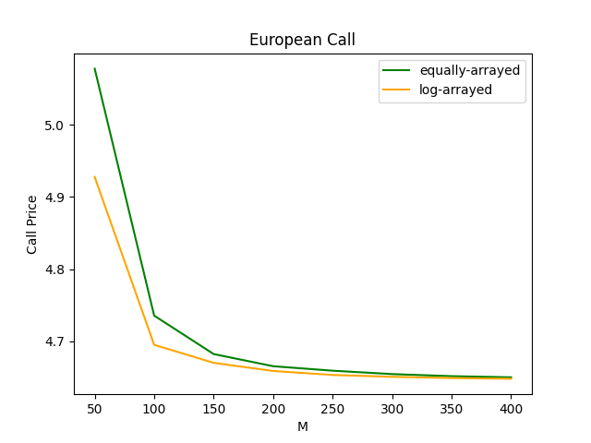

圖表的部分，可以觀察到 log-arrayed 的收斂速度快一點點。

**(2)Monte-Carlo: Option_Average_MonteCarlo.py**

*def* average_MC(*StAve*, *St*, *K*, *time_elapsed*, *time_left_to_maturity*, *r*, *q*, *sigma*, *n_prev*, *n*, *sims*, *rep*): ...

# main

St = 50

StAve = 50

K = 50

r = 0.1

q = 0.05

sigma = 0.8

time_left_to_maturity = 0.25

sims = 10000

rep = 20

n_prev = 100

n = 100

直接調整 **#main** 下面的變數，呼叫函式存入變數，再印出即可(所有參數以及函式都已預先輸入且用 **multiprocessing** 套件執行；直接執行即可以看到精美的結果)。

輸出看起來會是這樣 :

============================================================

Average Option : European Call

[ Save,t = 50 | time elapsed = 0 ]

------------------------------------------------------------

平均 : 4.641001

標準誤 : 0.092334

九十五趴信賴區間 : [4.456332, 4.825669]

...

**(3)Bonus2: Search_Algo_Comparison.py**

*def* binary_search(*array*, *x*, *low*, *high*):...

*def* interpolation_search(*array*, *x*, *low*, *high*):...

*class* Tree_Node:...

*def* average_CRR(*StAve*, *StInit*, *K*, *time_elapsed*, *time_left_to_maturity*, *r*, *q*, *sigma*, *M*, *layers_prev*, *layers*, *type*):...

*def* average_CRR_binary(*StAve*, *StInit*, *K*, *time_elapsed*, *time_left_to_maturity*, *r*, *q*, *sigma*, *M*, *layers_prev*, *layers*, *type*):...

*def* average_CRR_interpolation(*StAve*, *StInit*, *K*, *time_elapsed*, *time_left_to_maturity*, *r*, *q*, *sigma*, *M*, *layers_prev*, *layers*, *type*):...

# main

StInit = 50

StAve = 50

K = 50

r = 0.1

q = 0.05

sigma = 0.8

time_left_to_maturity = 0.25

M = 100

layers_prev = 100

layers = 100

直接調整 **#main** 下面的變數，呼叫函式存入變數，再印出即可(所有參數以及函式都已預先輸入且用 **multiprocessing** 套件執行；直接執行即可以看到精美的結果)。

輸出看起來會是這樣 :

============================================================

{ Sequential Search }

============================================================

[ Save,t = 50 | time elapsed = 0 ]

------------------------------------------------------------

(CRR Binomial Tree) Price of European Average Call : 4.7354

============================================================

[ Save,t = 50 | time elapsed = 0.25 | previous layers = 100 ]

------------------------------------------------------------

(CRR Binomial Tree) Price of European Average Call : 2.3795

============================================================

[ Save,t = 50 | time elapsed = 0.25 | previous layers = 100 ]

------------------------------------------------------------

(CRR Binomial Tree) Price of American Average Call : 2.5079

============================================================

[ Save,t = 50 | time elapsed = 0 ]

------------------------------------------------------------

(CRR Binomial Tree) Price of American Average Call : 5.4146

Process finished in 5.4 second(s).

============================================================

{ Binary Search }

============================================================

[ Save,t = 50 | time elapsed = 0 ]

------------------------------------------------------------

(CRR Binomial Tree) Price of European Average Call : 4.7354

...